Hospital Performance Dashboard

### **KPI Cards**

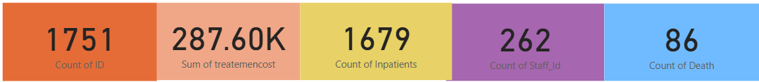

* **Key Findings**
  + Total Patients (IDs): **1,751**
  + Total Inpatients: **1,679**
  + Total Treatment Cost: **₹287.60K**
  + Total Staff Involved: **262**
  + Total Deaths: **86**
* **Insight**  
  Inpatients form the **majority of patient traffic**, and the death rate **(~4.9%)** is moderate. Cost per patient is roughly ₹164.
* **Recommendation**
  + Monitor death trends to improve critical care.
  + Conduct regular performance reviews of inpatient services

**Total Patient by Age**

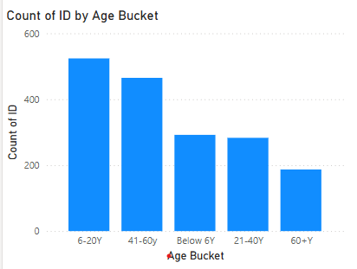

* **Key Findings**  
  Patients aged **6–20 and 41–60** form the largest groups.
* **Insight**  
  Youth and middle-aged adults are the most frequent visitors, possibly due to physical injuries and lifestyle-related health issues.
* **Recommendation**
  + Focus on **adolescent health programs** and **middle-age wellness campaigns**.
  + Tailor preventive care services for these high-volume groups.

**Inpatient and Outpatient by Weekday Name**

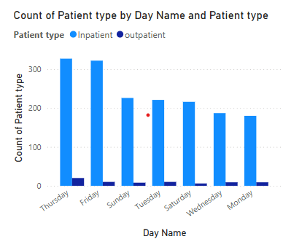

* **Key Findings**  
  Most visits occur on **Thursday and Friday**, and **outpatients far exceed inpatients** on all days.
* **Insight**  
  Patients prefer end-of-week appointments, possibly due to work/school schedules.
* **Recommendation**
  + Distribute appointments more evenly through **slot-based booking.**
  + Allocate **more staff/resources on Thursdays and Fridays**

**Status Based on Patient**

. 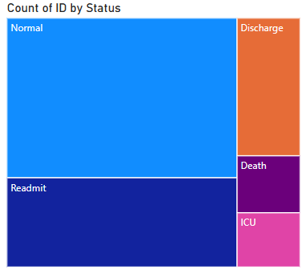

* **Key Findings**  
  Most patients are marked as **Normal (882),** followed by **Readmit, Discharge, ICU,** and **Death.**
* **Insight**  
  High "Readmit" count suggests possible gaps in **follow-up care or discharge planning.**
* **Recommendation**
  + Enhance **post-treatment monitoring** and discharge protocols.
  + Investigate causes of readmission to reduce recurrence.

**Department Analysis**

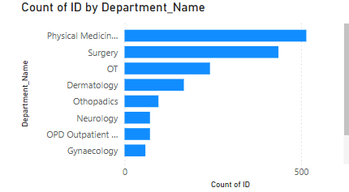

* **Key Findings**  
  **Physical Medicine & Rehabilitation** and **Surgery** have the highest patient volumes.
* **Insight**  
  These departments are crucial to hospital operations and likely handle both post-operative and chronic care patients.
* **Recommendation**
  + Allocate more **budget and staffing** to top-performing departments.
  + **Investigate underutilized departments** for potential service gaps or awareness issues.

### 

#### ****Key Findings****

* + **Cardiology** leads with ₹79.48K (27.64%).
  + **Dermatology** follows with ₹66.86K (23.25%).
  + **OT (Operation Theatre)** comes next with ₹38.14K (13.26%).
  + These three departments together contribute **~64% of the total treatment cost**.
* **Insights**
  + **Cardiology** is typically cost-intensive due to diagnostics, interventions, and critical care.
  + **Dermatology’s high cost** suggests either a **large volume of patients** or the use of **expensive treatments** like laser therapy or biologics.
  + **OT expenses** reflect the high cost of surgeries, anesthesia, and sterile materials.

### **Recommendations**

* + For **Cardiology:** Implement preventive programs (e.g., hypertension, cholesterol screening) to reduce the number of high-cost interventions.
  + For **Dermatology**: Review commonly used treatments to ensure cost-effectiveness; consider offering cost-saving alternatives where possible.
  + For **OT**: Audit surgical inventory, optimize procedure scheduling, and adopt minimally invasive techniques to reduce resource consumption.

**Region Analysis**

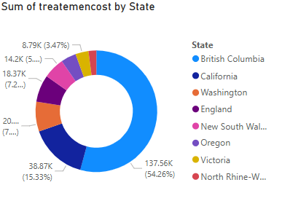

#### ****Key Findings****

* **British Columbia** has the **highest cost** (₹137.56K, 54.26%), followed by **California** (15.33%) and **Washington** (7.24%).

#### ****Insights****

* These three states account for over **75%** of total treatment costs, indicating **high patient load or expensive care.**

#### ****Recommendations****

* Audit top states to identify cost drivers.
* Promote **preventive care** and use **telemedicine** to reduce pressure.
* Improve **efficiency** in treatment delivery and billing practices.

**Gender-wise Analysis**

#### 

#### ****Key Findings****

* The **male population** has a **higher representation** across almost all departments, with particularly high counts in **Cardiology and OT**, while **females are notably represented in Gynaecology and Dermatology.**

#### ****Insight****

* This reflects **gender-specific healthcare utilization trends**. Some departments show balanced engagement, but others may lack tailored services or awareness for one gender.

#### ****Recommendation****

* Promote **targeted health awareness campaigns** for underrepresented genders in relevant departments (e.g., increase male outreach in Gynaecology-related screenings like prostate or urology).
* Ensure **gender-sensitive care policies and staff training** to improve satisfaction and outcomes.